Program:TextView and EditText
Activity_main.XML
<?xml version="1.0" encoding="utf-8"?>
<LinearLayout xmlns:android="http://schemas.android.com/apk/res/android"
android:layout_width="match_parent"
android:layout_height="match_parent"
android:orientation="vertical">

<TextView
android:id="@+id/txt_hello"
android:layout_width="match_parent"
android:layout_height="100dp"
android:gravity="center"
android:text="Hello world" />

<TextView
android:id="@+id/txt_hello"
android:layout_width="match_parent"
android:layout_height="100dp"
android:gravity="center"
android:text="Hello world" />

<EditText
android:id="@+id/txt_hello"
android:inputType="textPassword" android:layout_width="match_parent"
android:layout_height="100dp"
android:gravity="center"
android:text="Hello world" />

<EditText
android:id="@+id/txt_hello"
android:layout_width="match_parent"
android:layout_height="100dp"
android:gravity="center"

android:text="Hello world" />

</LinearLayout>
MainActivity.java
package com.example.myapplication;

import android.app.Activity;
import android.os.Bundle;

import com.example.myapplication.R;

public class MainActivity extends Activity {

@Override
protected void onCreate(Bundle savedInstanceState) {
super.onCreate(savedInstanceState);
setContentView(R.layout.activity_main);

}

}
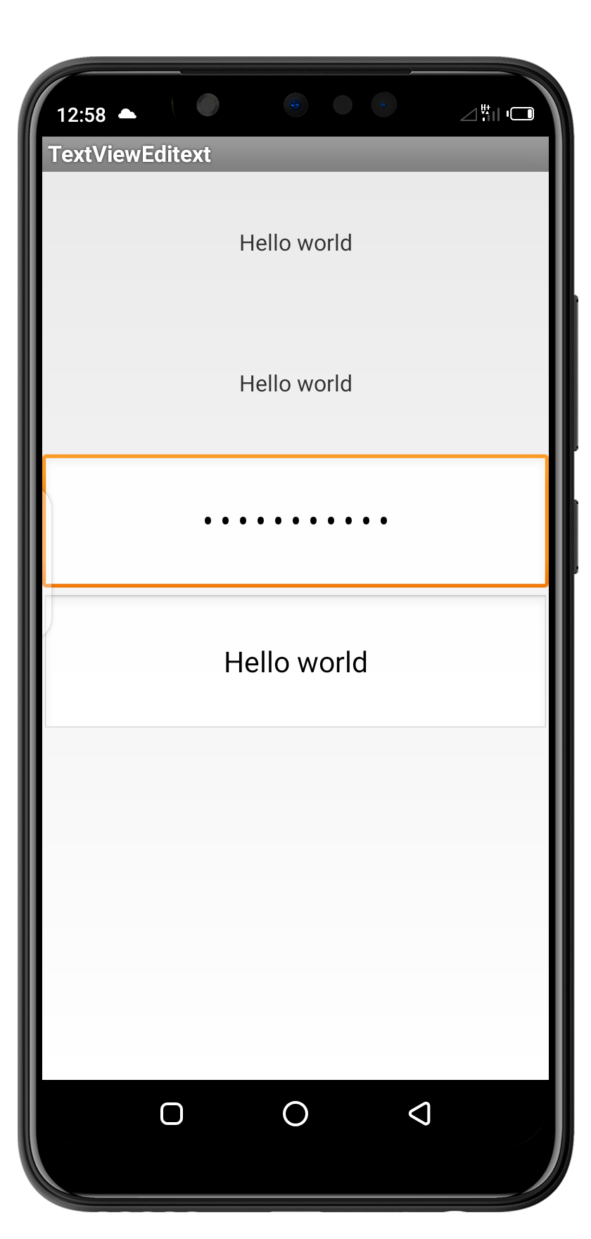
Output:

